Name | Swayam Ramdin
Roll no | 24204B0061
Batch | 03
Subject name | Python Programming & Data Structure
Teacher Name | Ms. Rasika Patil

Experiments | 13
Title | *Implement sorting techniques using python  a) Bubble Sort  b) Selection Sort  c) Insertion Sort

Programming Questions with Answer
1 | Program for Bubble Sort  arr = [64, 34, 25, 12, 22, 11, 90]
SCRIPT | arr = [64, 34, 25, 12, 22, 11, 90]  n = len(arr)  for i in range(n):  for j in range(0, n - i - 1):  if arr[j] > arr[j + 1]:  arr[j], arr[j + 1] = arr[j + 1], arr[j]  print("Sorted array:", arr)
OP
2 | Program for Selection Sort  arr = [64, 25, 20,10,30,12, 22, 11]
SCRIPT | arr = [64, 25, 20, 10, 30, 12, 22, 11]  n = len(arr)  for i in range(n):  min_index = i  for j in range(i + 1, n):  if arr[j] < arr[min_index]:  min_index = j  arr[i], arr[min_index] = arr[min_index], arr[i]  print("Sorted array:", arr)
OP
3 | Program for Insertion Sort  arr = [12, 11, 13, 5, 70,56,71,85,6]
SCRIPT | arr = [12, 11, 13, 5, 70, 56, 71, 85, 6]  for i in range(1, len(arr)):  key = arr[i]  j = i - 1  while j >= 0 and arr[j] > key:  arr[j + 1] = arr[j]  j -= 1  arr[j + 1] = key  print("Sorted array:", arr)
OP
Debugging Questions with Corrected Answers
1 | Debug the following code  Wrong code:  for i in len(arr):  for j in len(arr)-1:  if arr[j] > arr[j+1]:  swap(arr[j], arr[j+1])
OP | Error: 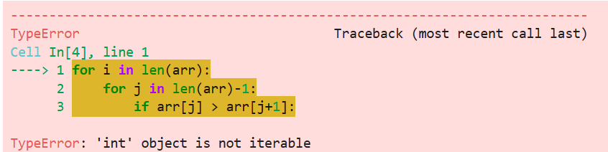  Correct code:  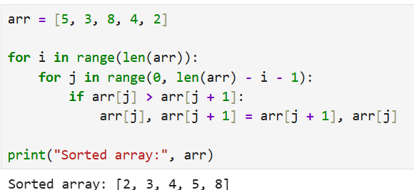
2 | Debug the following code  Wrong code:  for i in range(1, arr):  key = arr[i]
OP | Error: 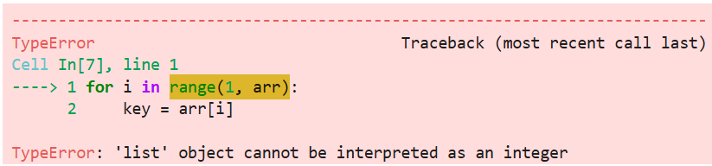  Correct code:  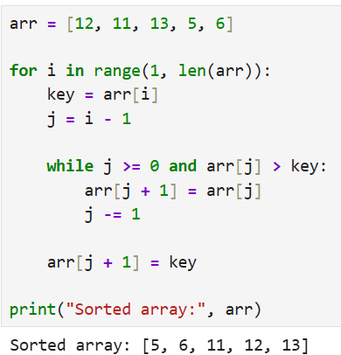
Conclusion

Performance Indicators |  | Teachers Dated and Signature
Process Related  (15 M) | Product Related  (10 M) | Total (25 M)

